Fast **National University of Computer & Emerging Sciences, Karachi  
Midterm – II (Fall-2023)**

**8th November 2023, 11:30 AM – 12:30 PM**

|  |  |  |
| --- | --- | --- |
| **Course Code: CS2007** | **Course Name: Human Computer Interaction** | |
| **Instructor Name: Iqra Fahad** | | |
| **Student Roll No:** | | **Section No: BSE 3A/3B** |

***Instructions:***

* Return the question paper and make sure to keep it inside your answer sheet.
* Read each question completely before answering it. There are **3 questions and 1 page**.
* In case of any ambiguity, you may make assumption. But your assumption should not contradict any statement in the question paper.
* Questions needs to be answered in order otherwise it will not be graded.
* You are **not allowed to write** anything on the question paper.
* Points and part wise distribution of each question is mentioned
* You can use colors/markers etc., wherever required.

___________________________________________________________________________

**Time**: 60 minutes. **Max Marks**: 30 Points

|  |
| --- |
| **Question 01**  **Estimated allocated time:** 40 minutes  **Points:** 5+5+5+5  **CLO:** 04 |

1. Differentiate between Incremental and Evolutionary prototype with the help of suitable illustration. State two major differences. Also specify which approach you are following for your project.

***Incremental Prototyping***

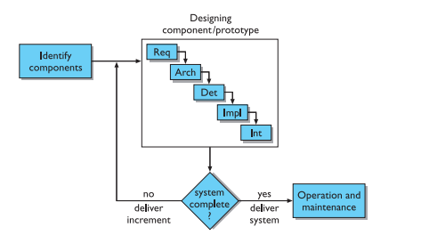

***Evolutionary Prototyping***

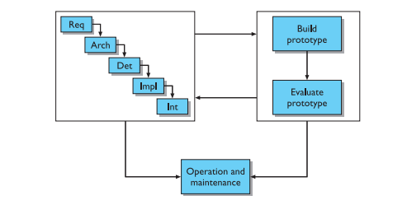

| ***Incremental Prototyping*** | ***Evolutionary Prototyping*** |
| --- | --- |
| *Developed in small, manageable increments, with each increment adding new features or refining existing ones.* | *Initial prototype is built with basic features, and the system evolves through continuous refinements and iterations.* |
| *User feedback is gathered at the end of each increment, influencing subsequent development.* | *User involvement is continuous throughout the development process, with ongoing feedback shaping the evolving prototype.* |

*We are using Evolutionary prototypes in our semester project.*

1. What is the formality gap in HCI? Support your answer with an example.

*The formality gap in Human-Computer Interaction (HCI) can also be defined as the difference in the user's mental model of how a system should work and the actual design or behavior of the system. It is the gap between users' expectations and the system's response, which can lead to confusion or frustration.*

*For example, if users have a mental model of a file system based on physical documents (folders, files, etc.), but the digital system organizes files differently, there is a formality gap. Closing this gap would involve designing the system's interface and interactions in a way that aligns more closely with users' mental models and expectations, reducing cognitive dissonance and improving usability.*

1. Which design rule(s) recently introduced WhatsApp Channels violate? State at least two of them with brief explanation.

*Redundancy, learnability, consistency.*

1. Imagine you are testing a screen recording app on a mobile phone. This app offers a unique feature where it converts all voices from the recorded videos into text. A user is trying to record a video of a live event using the app. The event features multiple speakers and ambient noise from the crowd. As the user attempts to capture the event, they encounter various issues. Identify and describe the usability problems or challenges the user may face when attempting to use this screen recording app with voice-to-text conversion during a live event. Suggest potential solutions or improvements to address the usability issues you identified. How can the app be enhanced to provide a better user experience in this scenario?

| ***Usability Problems/Challenges*** | ***Potential Solutions/Improvements*** |
| --- | --- |
| *1. Accuracy of Voice-to-Text Conversion* | *1. Implement advanced audio processing for noise reduction.* |
| *2. Identification of Speakers* | *2. Integrate speaker identification technology for labeling.* |
| *3. Ambient Noise Interference* | *3. Provide user-controlled settings for sensitivity.* |
|  | *4. Offer real-time feedback and easy editing capabilities.* |
|  | *5. Prioritize main speakers and allow user customization.* |
|  | *6. Include contextual information in transcriptions.* |

|  |
| --- |
| **Question 02**  **Estimated allocated time:** 10 minutes  **Points:** 5  **CLO:** 02 |

What are toolkits in windowing system and what are their properties? Provide illustrated examples to support your answer.

***Definition:*** *Toolkits are sets of libraries providing GUI elements for graphical applications.*

***Widgets:*** *Include pre-built components like buttons, text boxes, sliders.*

***Event Handling:*** *Mechanisms for managing user interactions, such as clicks and inputs.*

***Layout Management:*** *Systems to organize and arrange GUI components within windows or panels.*

***Drawing and Rendering:*** *Functions for rendering graphical elements on the screen.*

***Cross-Platform Compatibility:*** *Often designed to be cross-platform for broader application deployment.*

|  |
| --- |
| **Question 03**  **Estimated allocated time:** 10 minutes  **Points:** 5  **CLO:** 03 |

MailChimp is a platform that provides email marketing solutions to its clients. Here is one of its screens:

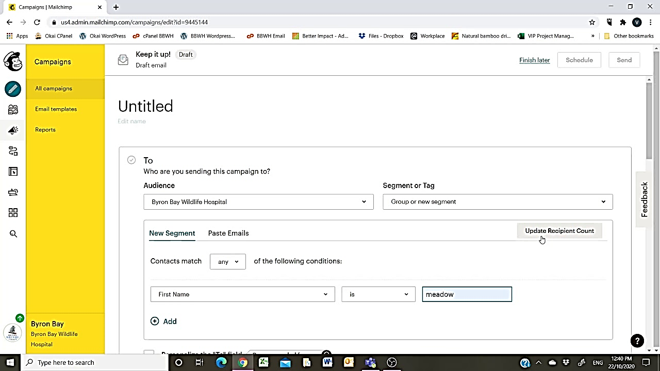

Perform Heuristics Evaluation on this screen only, and write about 3 heuristics applied on this screen.

*Here are three heuristics applied to the MailChimp screen:*

***Visibility of System Status:***

***Application:*** *Ensure clear indicators or feedback about the status of email campaigns, making it easy for users to understand the progress of their actions.*

***Recognition Rather than Recall:***

***Application:*** *Design the interface to minimize cognitive load, allowing users to easily recognize and access key features without relying on memory.*

***Consistency and Standards:***

***Application:*** *Maintain a consistent design language and layout across the screen, including terminology, button placements, and visual elements, to enhance user predictability.*